IHG arrival report and to send the upgrade email:
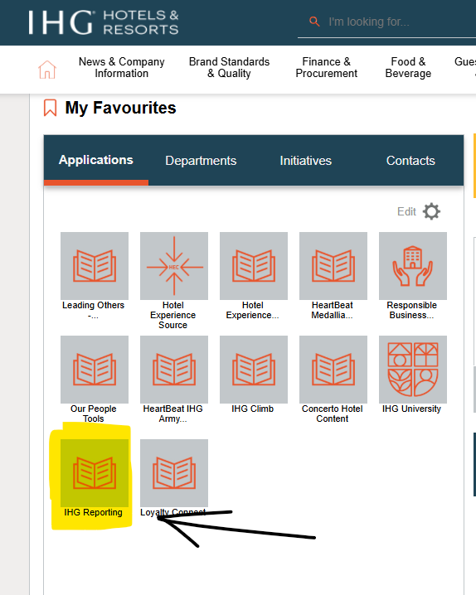
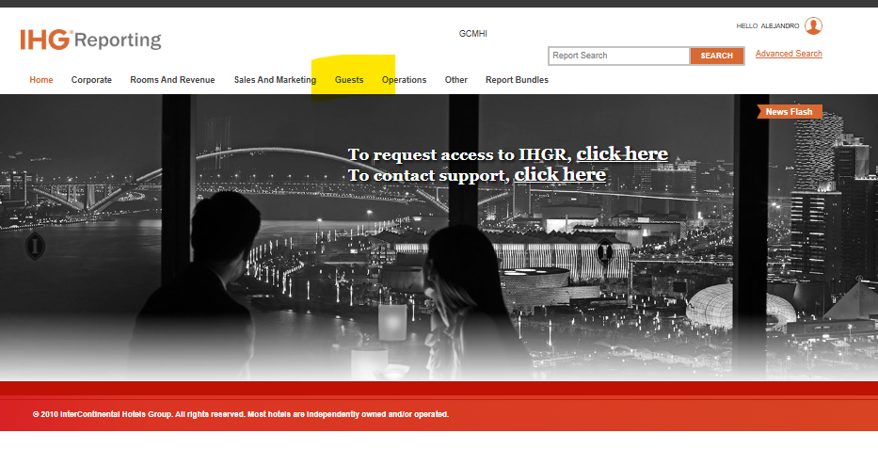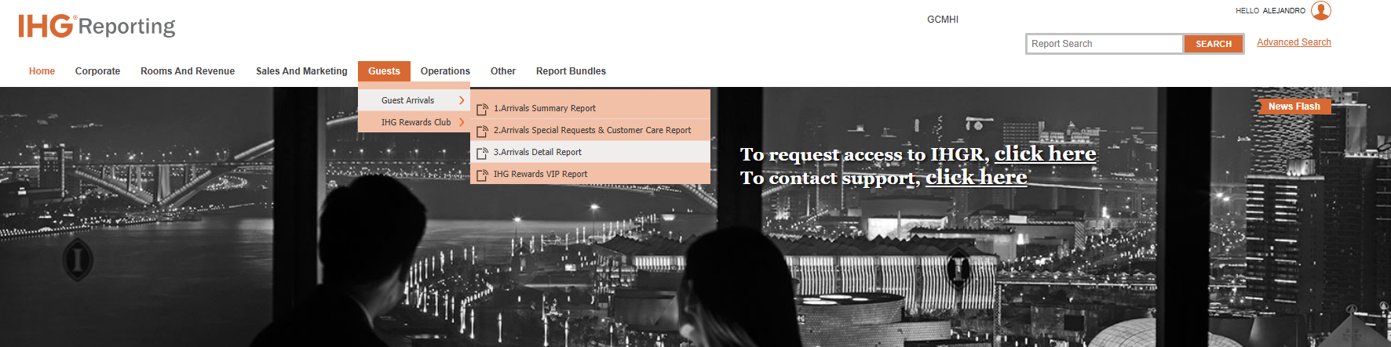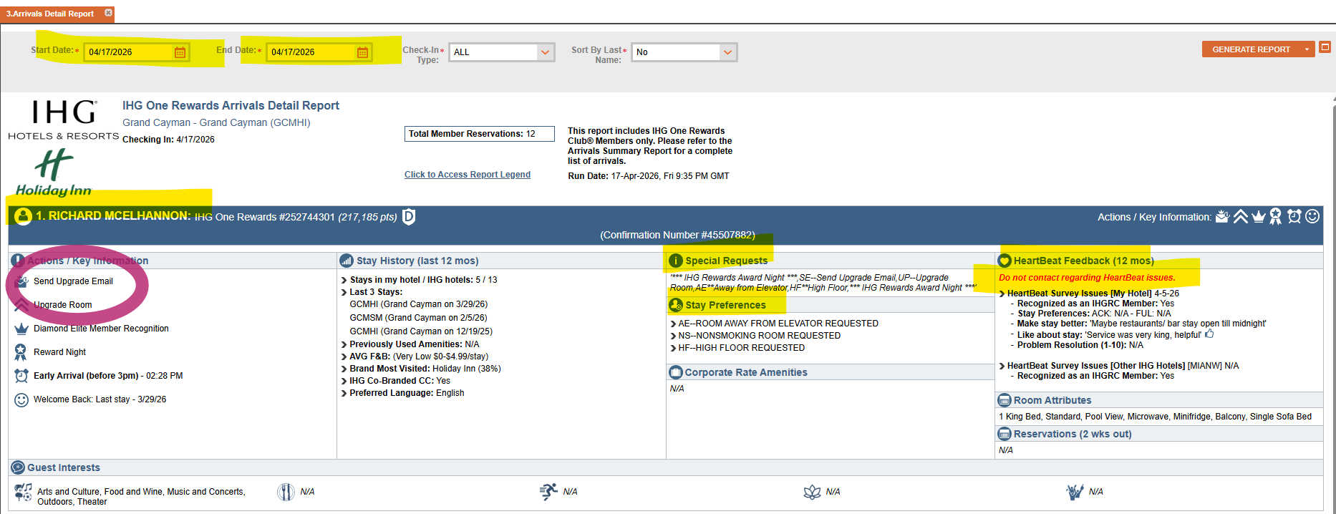

IHG rewards manual redemption:

https://ihg.service-now.com/liftportal/home.do

Business Service: Loyalty Voucher HAPI Platform
Situation: Reimbursement issue [Incident]
Short Description: MR. MBR-XXXXXXXXX. CONF-XXXXXXXXXXX
Description:
- Property Code: XXXXX
- Member Name:
- Membership Number:
- Reservation CRS Number (8 digit):
- Check-in date:
- Voucher redeemed date:
- Number of vouchers redeemed:

You must also ensure that a screenshot from the OPERA billing screen that clearly shows both the manual redemption posted to transaction code 9282 as well as the F&B transaction codes to which the vouchers have been applied is attached to the ticket.
If the F&B charges are collapsed or included in a package, please expand the posting(s) to show the transaction codes included. (click on the “+” sign next to the postings to expand them).
Please note that a folio printout can’t be used to validate the F&B charges as it doesn’t display the transaction codes.
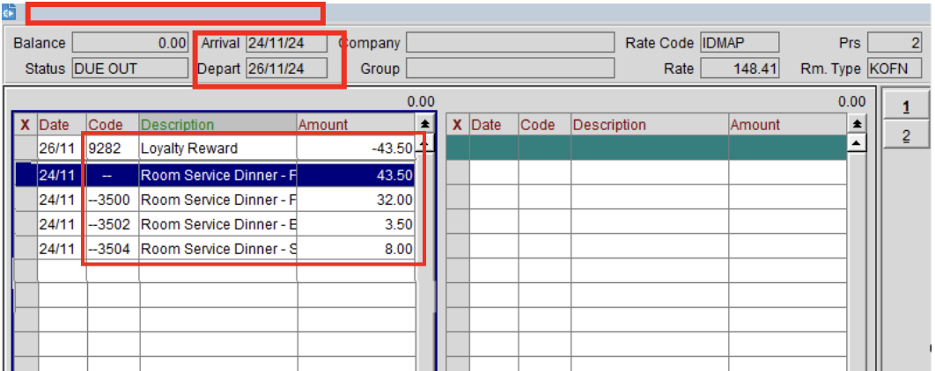
Remove the rewards
